**Lab Task 4.1**

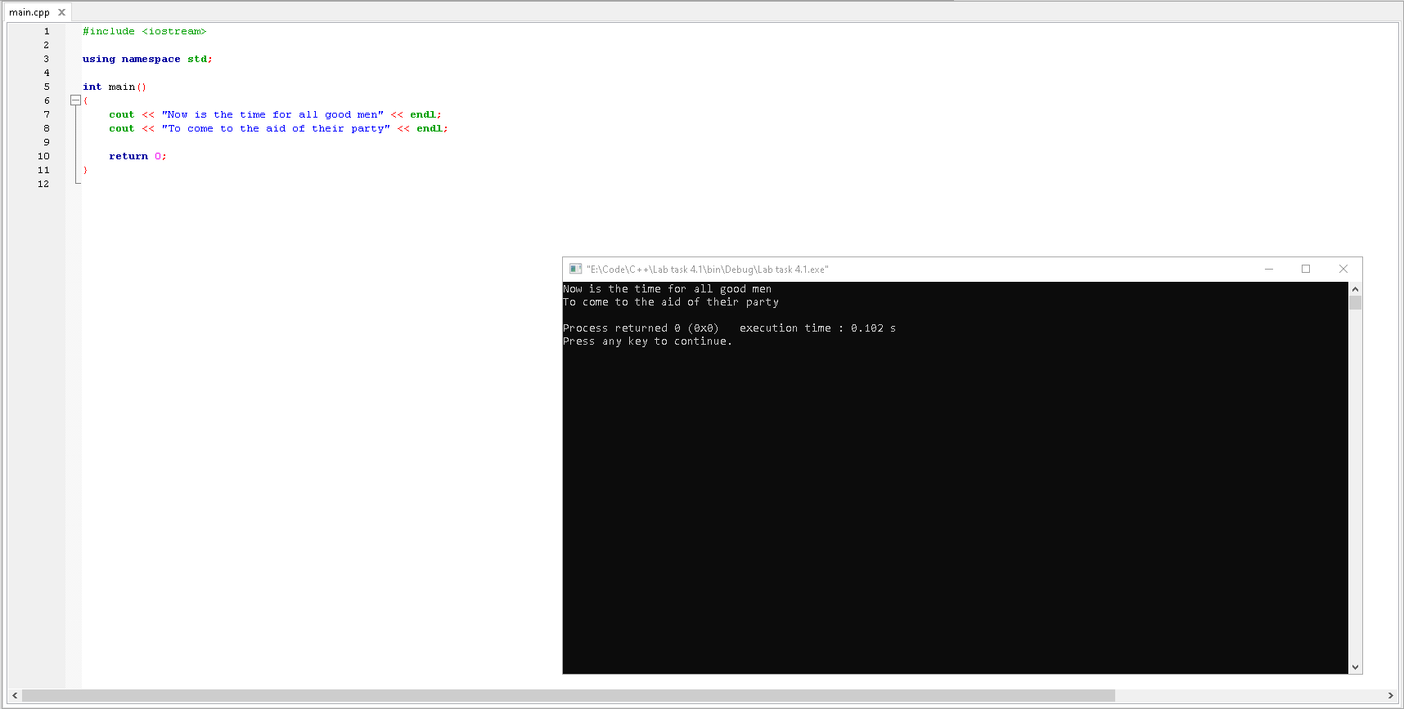

Observation: The program outputs the content within the quotation marks on both lines.

**Lab Task 4.2**

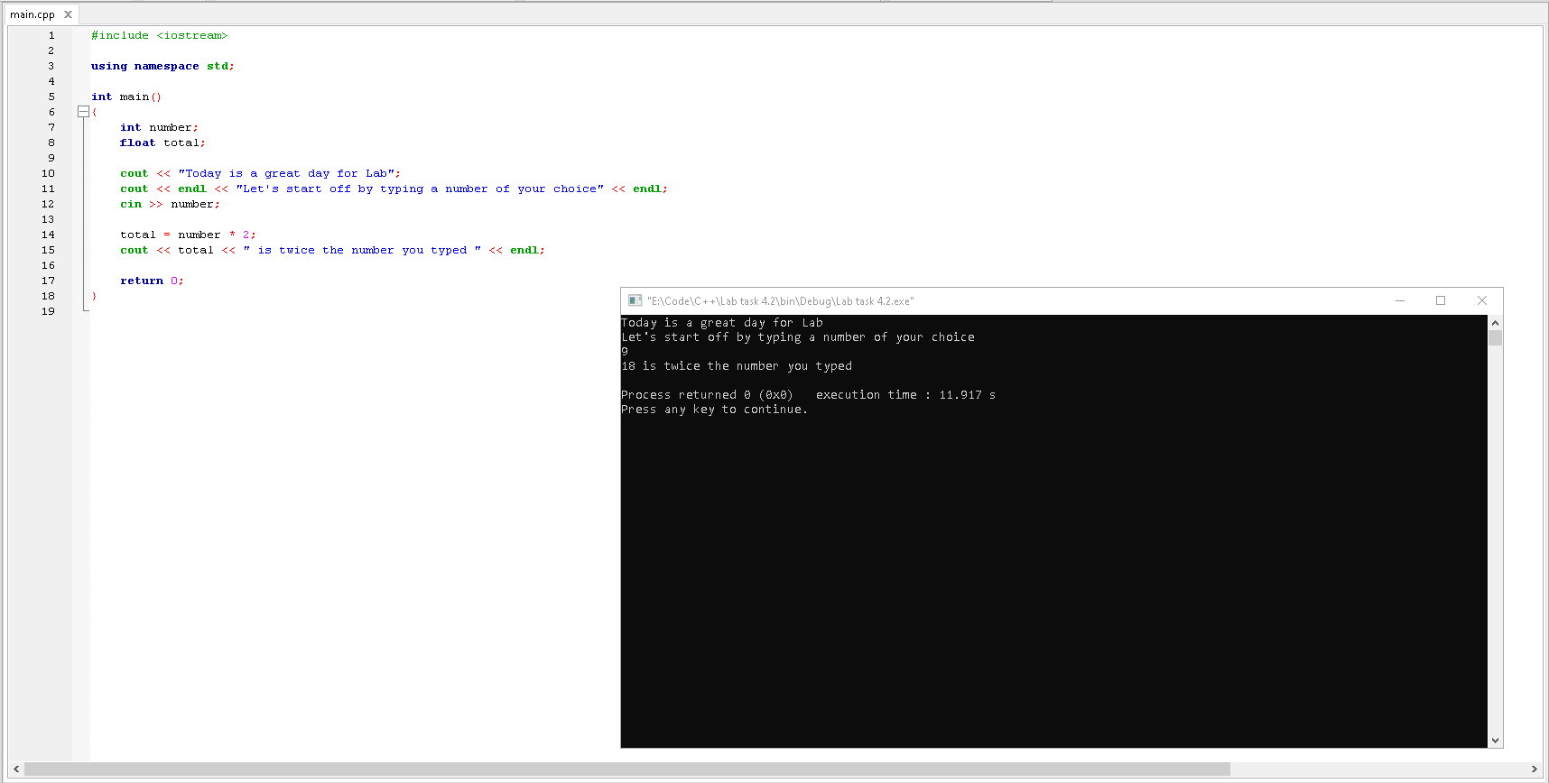

Observation: At the start, the program is initialized with some variables and the classes they belong to.

Then, the program outputs the content within the quotation marks on both lines and asking the user to

input a number. The program multiplies the number by 2 and outputs the answer with also some content

within the quotation marks.

**Lab Task 4.3**

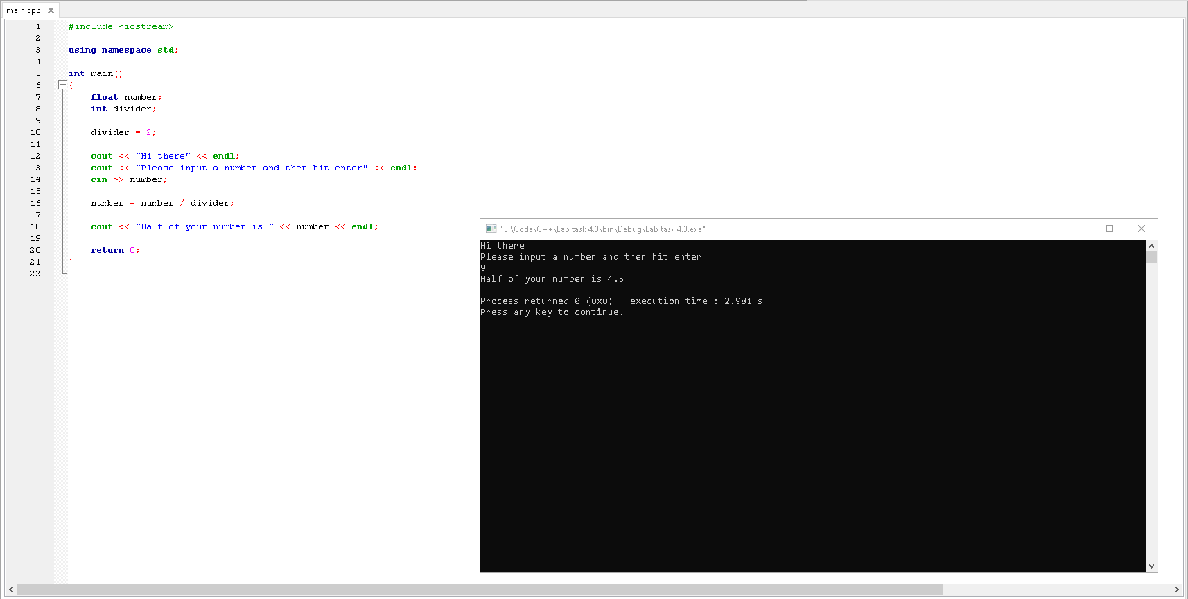

Observation: At the start, the program is initialized with some variables and the classes they belong to

and followed by storing a number in the “divider” variable. The program then outputs the content within

the quotation marks on both lines and asks the user to input a number. The program then halves the

number and informs the user about the answer.

**Lab Rask 4.4**

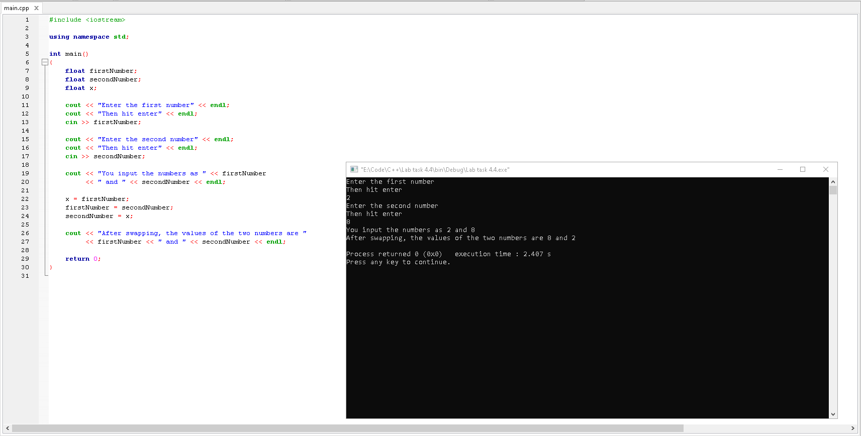

Observation: At the start, the program is initialized with some variables and the classes they belong to

and prompts the user with content within quotation marks and asks to input 2 numbers (First number and

Second number). It then tells the user what number he/she have put in and then swaps both numbers

making first number the second number and vice versa followed by prompting the user the swapped

numbers.

**Post Lab Task**

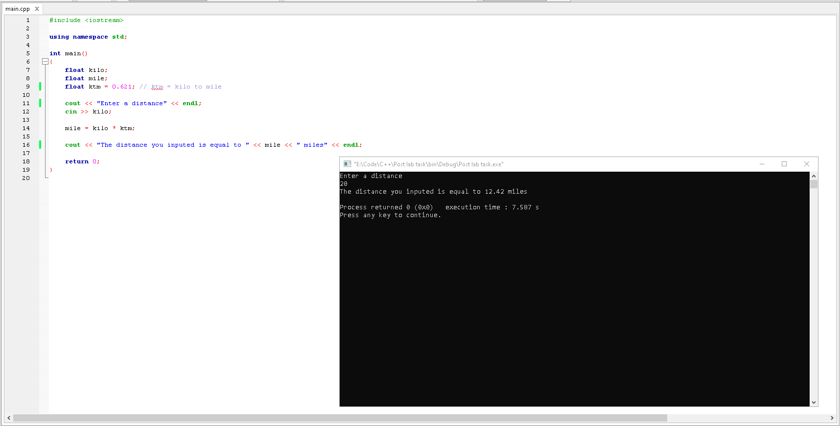

Observation: At the start, the program is initialized with some variables and the classes they belong to

followed by storing a value in the “ktm” variable. The program then asks the user to input a distance,

multiples the number with the value stored in “ktm,” converting the distance in kilometers to the distance

in miles and outputs the answer.